## **Photographic Essay: The Struggle for Clean Water**

**Introduction**

Access to clean water is a fundamental human right, yet many rural African communities face daily challenges in securing safe and sufficient water. This photographic essay explores the struggles, solutions, and impacts of clean water initiatives in these communities.

## Establishing Shot

A view of a rural African villagers, where access to clean water is a daily struggle."

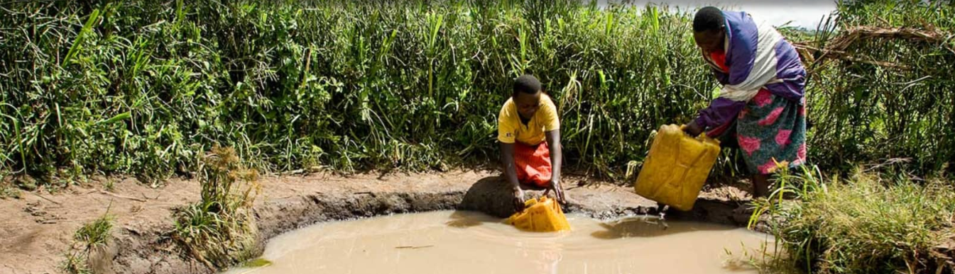

## Daily Life

Woman and her children walking long distances to collect water from a distant river.

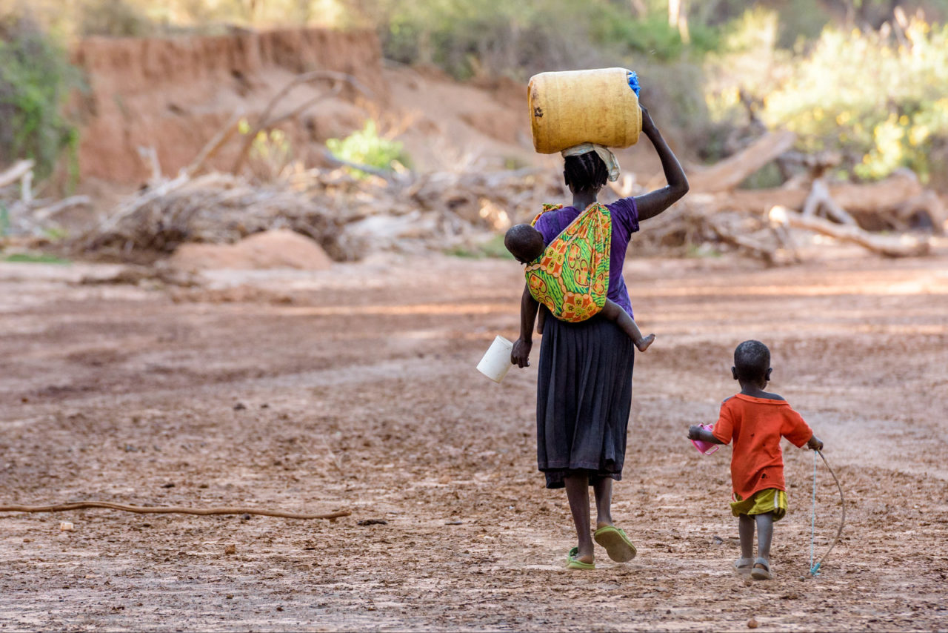

A child drinking from a contaminated water source, highlighting the health risks.

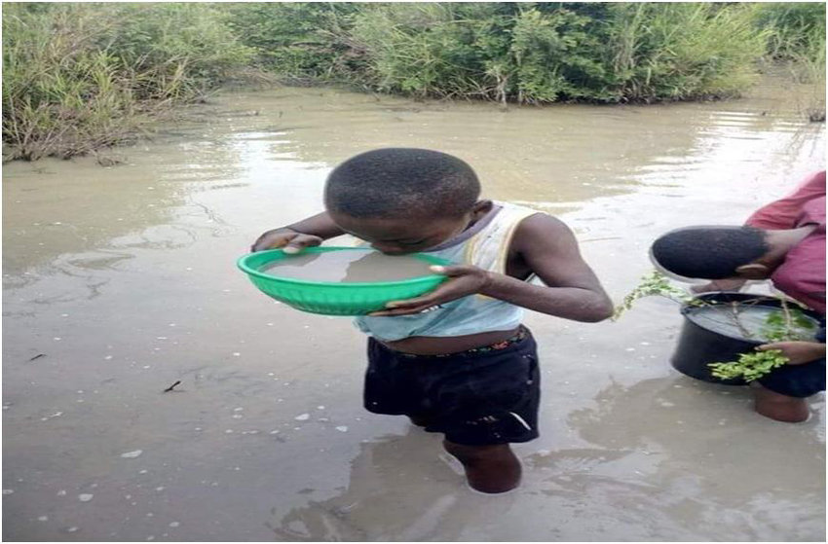

## Global recognition of water crisis

People advocating for clean water.

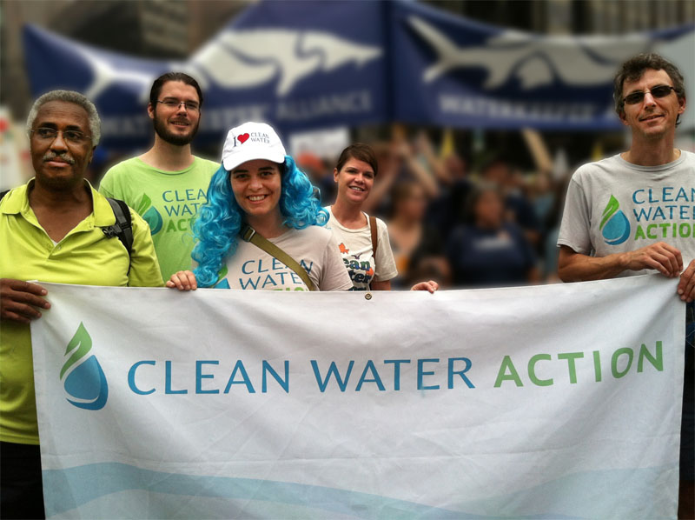

Local initiatives like rainwater harvesting systems being implemented.

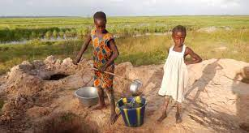

## Solutions

Installation of a new well bringing hope to the community.

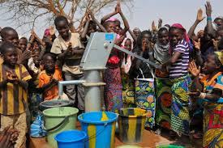

Water filtration systems providing safe drinking water.

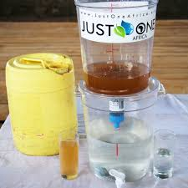

## Positive Impact

Children enjoying clean water, leading to better health and education opportunities.

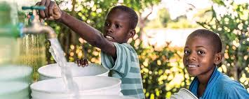

Community members expressing gratitude for the improved water access.



## Conclusion

Access to clean water transforms lives, providing health, education, and economic benefits. Continued support and innovative solutions are essential to ensure that every community can enjoy this basic human right. Join us in making a difference.